Commissions Information Trail

The “Knowledge Transfer” Project

August.30.2019

**─**

Susan Kraft-Yorke

Business Unit report

**Table of Contents**

Overview

Problem

Discussion of Salesforce, Callidus, Training, and Commissions

Salesforce Product Listings

Sales Callidus Reconciliation Tool

Callidus Reconciliation Tool

Callidus Reconciliation Tool V-2

Online Sales Training Opportunities

Reconciliation Tool

NOTE: To get a quick overview of the tool look and feel, watch this short video, Agent Reconciliation Tool - US Accountant Payroll Segment Overview.mp4.

Salesforce Training Modules Library

Salesforce to Callidus Logic Flow

ABC Sales to Commission Flow

ABC Sales Rules

ABC Workflow and Commission Trigger Events

Salesforce

Data Flow

Conclusion

Appendix

Commission Fields

Meeting Minutes RE: Commissions Challenges

Managing Calculation Rules and an Outsider’s View

KT Papers, presentations, and Wiki links

Box links

Past Wiki links

Live presentations

Using Salesforce to see a lead, accounts, and opportunities

Payments and NextGen

Excel Summary Sheets - a summary of her last thoughts on Salesforce, Callidus and Commissions

SOW and links tab

Background tab

Payments tab

Salesforce

Product System

Billing System (A-product)

Order tab

Sales Teams tab

Examples Callidus Stage in SF tab

Managed tab

# Overview

This document started as a knowledge transfer (KT) project from Staff Business Analyst, Ms. Smith to this author. The overview document she shared with me, “[Business Unit Attribution Rules & Forecasting Alignment](https://nolink.com)”, stated that a look at **data and differences in business rules** now were in alignment with the FY20 Project Blackbird.

Her April 2019 presentation highlighted a path to improve the forecasting process and increase visibility to the value contributed by Sales by improving forecasting and closing data gaps.

However the core of this documentation project is an investigation into commission adjustments gained through conversations, perusing Intuit’s website, Salesforce, Callidus and sales training. You can find the links to specific KT documents in the Appendix.

The main body of this document is a report on sales agent commission systems and its associated problems, training, and tools.

# Problem

Sales agents question their commissions data month after month. The compensation team attempts to stem the sales questions by combing through the data at the end of every month with some success.

This sales credit data comes from Callidus; sales reporting comes from finance. Commission reporting and sales reporting overlap but not exactly. Some sales agents are not confident they are paid accurately or timely which causes downstream pain and inefficiency, which again puts a **burden on the Compensation team** to make sure commissions are paid accurately and on time. These **sales agents spend hours each month doing their own reconciliation** which takes away from selling. If the problem of commission adjustments is left unchecked it will continue to use personnel resources on non-core business problems.

# Discussion of Salesforce, Callidus, Training, and Commissions

This section is a high level description of how data enters Salesforce and is delivered to Callidus. Some problems with commission adjustments are caused by erroneous data in Callidus. The erroneous data is a result of regular changes to the Callidus and Salesforce software, quarterly changes in corporate planning as regards sales commissions, and user errors. The biggest common factor is that communication channels connecting engineering, marketing, sales, and finance are bottlenecked, or over-complicated.

## 

## Salesforce Product Listings

There are five core products that spread across many product families. If you choose the wrong product family at the start of a Saleforce session, your commissions are derailed later in the process. To a novice, it seems improbable there are more family choices than core products.

*Table: Intuit Core products and product families*

|  |  |
| --- | --- |
| Core Products | Product Families |
| INTENTIONALLY LEFT BLANK FOR EXAMPLE DOC |  |

## Sales Callidus Reconciliation Tool

The Compensation team and Sales agents can look inside Calidus with a reconciliation tool to see what happened to individual sales. This is a tool to request or explore reconciliations.

### Callidus Reconciliation Tool

There are many potential causes for error introduction, such as user operator error (not following Salesforce data entry rules), data analysis errors, and bugs from upgrades or AWS migration.

The Sales Agents and the Callidus team have a commission reconciliation tool for Payroll Callidus entries in Quickbase sales management apps. It is a standard app as commission adjustments is a regular process within Sales organizations.

  
*Figure: Detail of the Compensation team Reconciliation tool V1 to search for missing data*

The Compensation team works overtime and weekends the last week of each month and the first few days of every month, checking Callidus with the Reconciliation Tool for adjustments to give the sales team the cleanest view into their commissions.

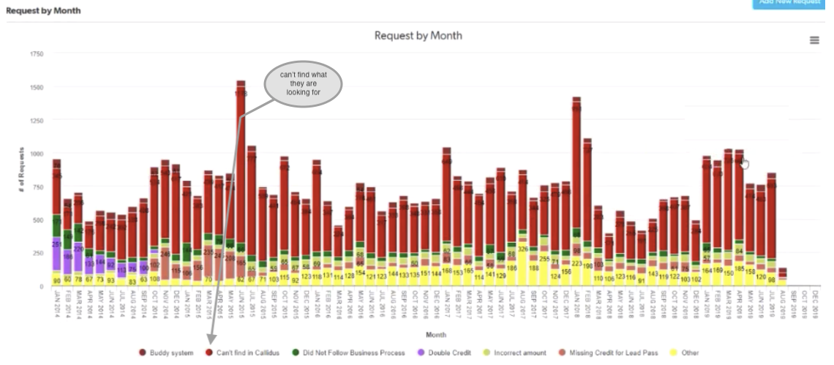*Figure: Corrections requests per month show the most frequent request is “Can’t find in Callidus” from the Callidus Reconciliation Tool V1*

With the reconciliation tool version-1, 50-80% of Compensation help requests are to investigate Callidus records for sales agents, as they cannot find what they are looking for, as shown in the previous bar graph.   
The largest pain point is missing data, which is a combination of data issues and manual data. The largest category for commission adjustment requests is 'order not in Callidus'. A significant set of those requests are 'invalid requests' because the order is not commissionable or it's a timing issue so that those data searches do appear in Callidus data tables a little later.

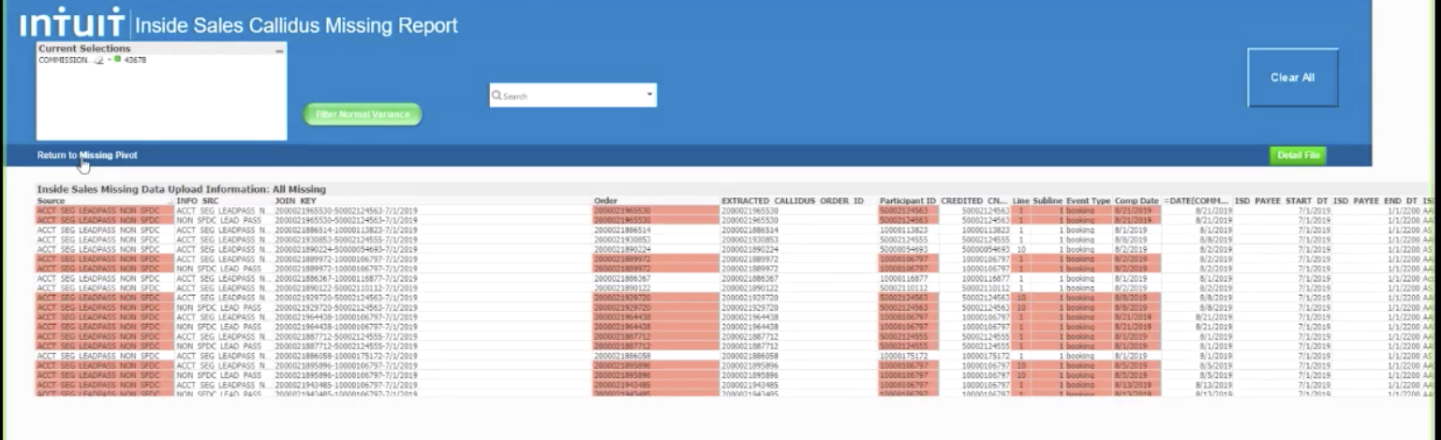

*Figure: Typical manual record search view inside Calidus (Reconciliation Tool V1)*

### Callidus Reconciliation Tool V-2

The next version of the reconciliation tool is designed to give a greater and easier view into the Callidus records to reduce the request overhead on the Compensation team.

Each sales team member individually **tracks their sales with Quickbase as a personal recordkeeping** method. Because each team sells different products and has different credit rules, each Quickbase team template is optimized accordingly. The Account Segment Team is the first sales team to have a version 2 tool built for them because they sell the widest variety of Intuit products.

The request records from this tool show there is a significant drop in requests for “Can’t find in Callidus”.



*Figure: Reconciliation tool V2 to search for missing data*

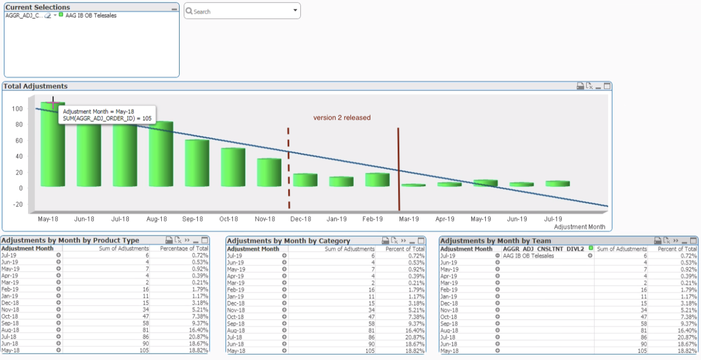

*Figure: Corrections requests per month showing the “Can’t find in Callidus” request dropped sharply after the Callidus Reconciliation Tool V2 was released*

## 

## Online Sales Training Opportunities

This section discusses accessibility to learning and training modules for Sales teams members. This is *important because* transparency and lack of understanding by Sales team members of what and how Collidus calculates commissions. This is one of the root causes for added work in the Callidus team and frustration in the sales team.

### Reconciliation Tool

Sales staff must learn to use the reconciliation tool before they can submit a request. The link for this class and tool are:

* Agent Reconciliation Tool, CRSE 1218922
* <https://nolink.com>

### **NOTE**: To get a quick overview of the tool look and feel, watch this short video, [Agent Reconciliation Tool - US Accountant Payroll Segment Overview.mp4](https://nolink.com).

### Salesforce Training Modules Library

The salesforce training modules library lacks an organizational structure. At the **top leve**l, the sub-menus overlap target pages, jump to dead pages, and use different typography styles. At the **class-choice level,** the groupings *lack* a standardized and intuitive structure. For example, there are at least two different paths to the Training Library page. This page shows dozens of Sales information packages including lessons on how to use Quickbooks and how to use the product to how to make a sale and be an influencer. While it is rich in many useful tutorials, it’s time consuming when sorting through the pages searching for a specific lesson due to categorizing by file type rather than content.

### 

## Salesforce to Callidus Logic Flow

The diagram in this section shows the commission automation logic processes. It begins with a sales **lead** and converts to a **commission.** (Diagram from Callidus Eng Team)

*Figure: Sales commission automation logic flow*

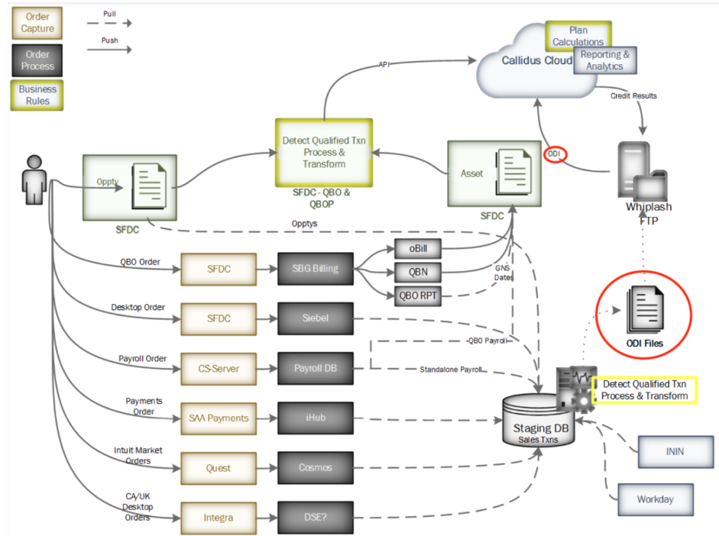

### ABC Sales to Commission Flow

Data management in the Sales commission automation logic flow diagram shows all product sales data processing to Callidus. There is one system that consumes and produces results inside Salesforce creating in a transaction table. An API sends that data over to Callidus and is saved as a record.

The only real-time process is for the ABC sales. For the rest of the products, we use a nightly cron-job where a Callidus integration layer runs a script to transform the data into simple on-demand integration (ODI) files to store sales data in temporary tables inside that staging database. Then we send these files to Callidus for processing.

***NOTE:***  *This overnight batch processing is not included in the AWS platform migration plan.*

### ABC Sales Rules

The following is a list of events that trigger commission events:

* 1st charge date for a commission check
* cancel date for a clawback
* (*QBOA)* migrate out date[1] for a commission check
* upgrade date (not working 100% because we don’t enforce the sales process without direct proof - as per engineer, Phil Hill)

***NOTE****: The following commission logic is non-standardized across products and platforms. Sometimes the* ***Sales crediting logic rules change without notice*** *to engineering so that the API triggers are not updated and become incorrect:*

* resubscription after a trial ends without an initial end-of-trial subscription, the clawback can be reversed during a 90-day or less period for a commission check
* suspend date (a passive cancel event) plus past grace period (last payment retry failure date) for a clawback

*Figure: Payroll data path*

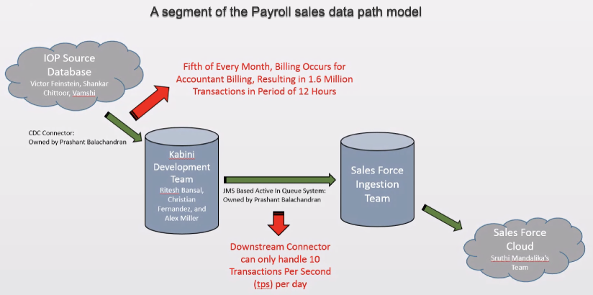

When data isn’t flowing as expected through the system, then commissions are adversely affected. Sr. Technical Data Analyst, Mr. Smith[2], runs a search upstream and finds the missing sale. Fowler notes the following issues are the primary reasons for data breakage.

* Agent behavior - mult-tasking and make mistakes
* There are many other systems connected together and therefore there are more risks

## ABC Workflow and Commission Trigger Events

### Salesforce

The following [diagram](https://drive.google.com/file/d/1u5XHcBEr4JmSBm9hhMfXHZaccqwppA4s/view?usp=sharing) shows ABC processing and qualifying leads logic. Any commissions are that may result in commissions (outlined in red).

*Figure: ABC processing and qualifying leads logic in Salesforce*

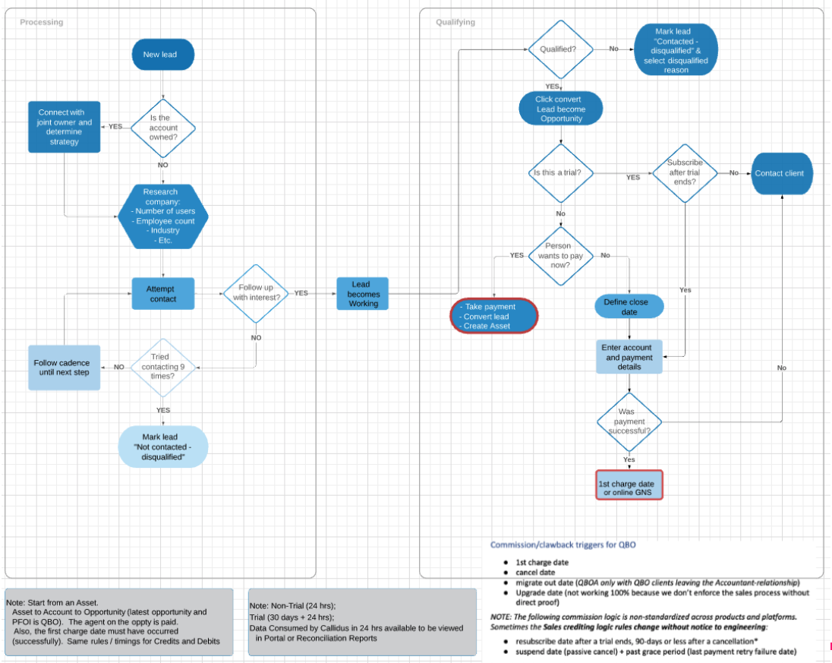

The Salesforce commission and workflow initial set-ups for ABC and ABC for accountants differ. The previous diagram only shows ABC workflow. However, once the sale or trial is defined, the data flow is the same. The following section describes the data flow.

## 

### Data Flow

The following [diagram](https://drive.google.com/file/d/10rtGJyfTZG7_C6k4l_OVXDpBobdgVZqf/view?usp=sharing) shows ABC/A commissions and clawbacks outlined in colors.   
  
*Figure: ABC/A data flow and commission results after processing a sale in Saleforce*  
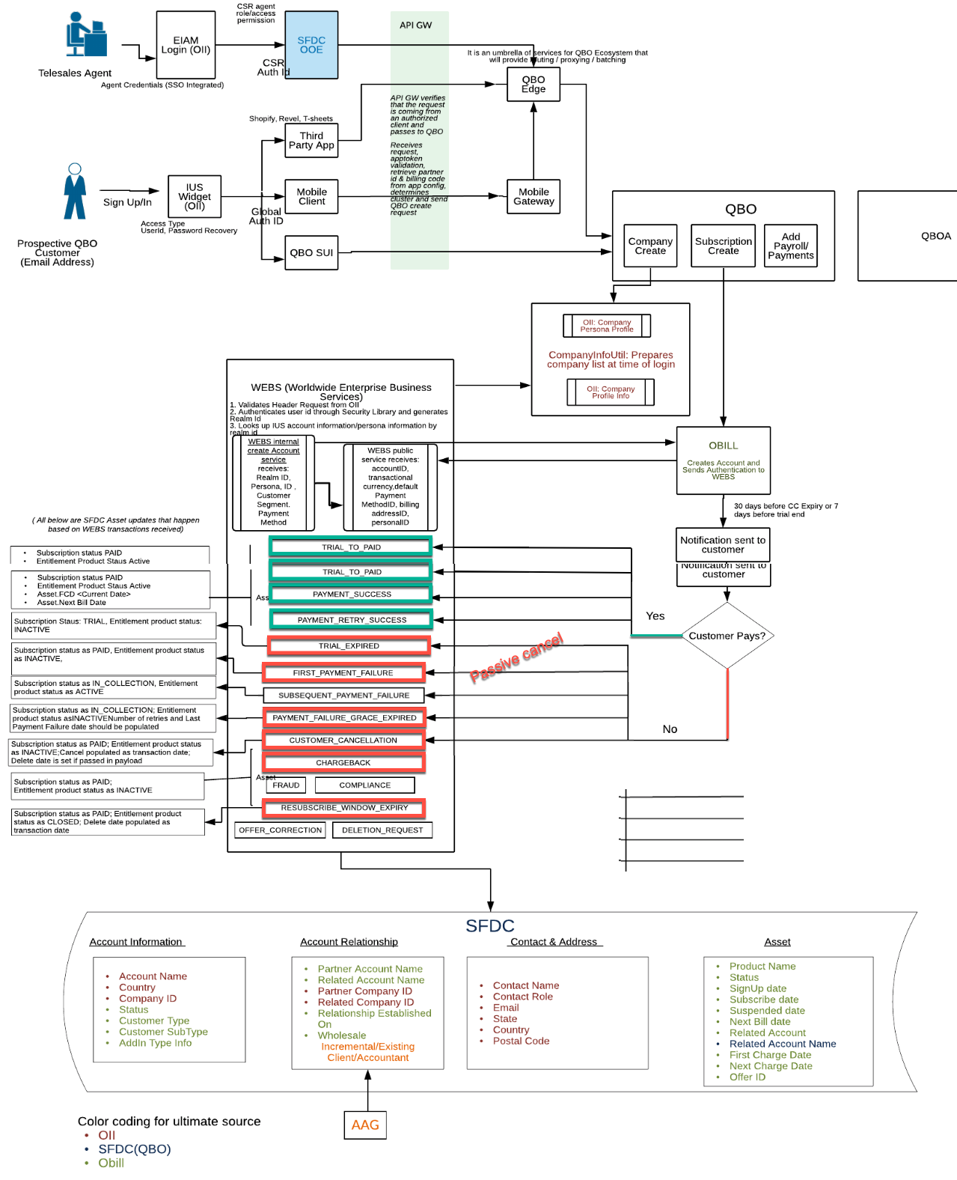

# Conclusion

Sales commission adjustments requests come from a few systemic issues:

* Complicated **rules logic for sales** compensation. The following are examples of downstream problems:
  + Not knowing when to calculate proration or double credits.
  + Client migration and resulting sales so when a client leaves an Accountant-relationship, the commission ownership can be uncertain.
  + Regular updates/changes to marketing sales rules limit Compensation team ability to [time-box update cycles](https://www.agilealliance.org/glossary/timebox/#q=~(infinite~false~filters~(postType~(~'page~'post~'aa_book~'aa_event_session~'aa_experience_report~'aa_glossary~'aa_research_paper~'aa_video)~tags~(~'timebox))~searchTerm~'~sort~false~sortDirection~'asc~page~1)) and stay in sync with sales expectations.
* **Lack of transparency for sales** staff results in low ability to resolve sales results questions:
  + The largest category for commission adjustment requests is 'order not in Callidus' due to non-commissionable orders or a premature research request,
  + Another significant sector of requests are from those, for a variety of reasons, who are unable to decipher Callidus charts[3].***NOTE****: a new Reconciliation tool is being developed and rolled out for the remainder of the products.*
  + Sales learning library is difficult[4] to search for specific answers.
* Compensation team**[5] lacks primary resources and secondary support**, specifically:
  + Internal maintenance and upgrade of Callidus releases lack QA & UAT support.
  + External Callidus support level agreement has poor service and often complicates problem-solving with delays or by lack of a solution.
* Sales Operations developed the “Sales Callidus Reconciliation Tool” to help sales **agents verify if sales credits** are correct in Callidus or if they need to request an audit.

# Appendix

This section contains information extending and supporting the main body discussion.

# Commission Fields

The following table shows Salesdforce fields that are commission triggers that pass sales credit information through the Sales Commission logic and data flow. (See [link to the source file](https://nolink.com), created by Sweta Parekh)

|  |  |  |  |  |  |  |  |
| --- | --- | --- | --- | --- | --- | --- | --- |
| **Product** | **Channel** | **Object** | **Field** | **Source System** | **Role for commissions** | **Criteria** | **Issues with it, if any** |
| **ABC (SimpleStart, Essentials, Plus, Advanced)** | **Accountant** | Asset | Online GNS Date | A-product | Booking | for WSB, on sign Up and NonWSB, on FCD | Low confidence in accuracy of FCD esp for QBN |
|  |  |  | Suspend | A-product | Clawback | when grace period is expired, suspend date is within 90 days of Online GNS Date | Logic in callidus and sales reporting does not match 100% |
|  |  |  | Migrate Out | A-product | Clawback | Migrate Out is within 90 days of online GNS Date |  |
|  |  |  | Cancel | A-product | Clawback | Cancel is within 90 days of Online GNS Date |  |
|  |  |  | ReSubscribe | A-product | Clawback offset | ReSubscribe is within 90 days of Online GNS Date |  |
|  |  |  | upgrade | A-product | upgrade |  |  |
|  |  | Relationship | AIC | ABC BC table in SFDC |  | Should be True to be commissionable | Manual Process, sometimes delayed |
|  |  |  | Relationship Established on | QBO |  | Should be > Online GNS Date, to be commissionable |  |
|  |  | Account Owner History | Owner | Salesforce | Payee | should be Accountant owner at time of GNS |  |
|  |  |  |  |  |  |  |  |
| **ABC (SimpleStart, Essentials, Plus, Advanced)** | **TeleSales** | Asset | Online GNS Date | A-product | Booking | Online GNS=FCD | Low confidence in accuracy of FCD esp for QBN |
|  |  |  | Suspend | A-product | Clawback | when grace period is expired, suspend date is within 90 days of Online GNS Date | Logic in callidus and sales reporting does not match 100% |
|  |  |  | Cancel | A-product | Clawback | Cancel is within 90 days of Online GNS Date |  |
|  |  |  | ReSubscribe | A-product | Clawback offset | ReSubscribe is within 90 days of Online GNS Date |  |
|  |  |  | Upgrade | A-product | upgrade |  |  |
|  |  | Opportunity | Oppty Creator | Salesforce | Payee | Determine Agent to give commissions |  |
|  |  |  | Oppty Owner (if diff) | Salesforce | Payee | Determine Agent to give commissions |  |
|  |  |  | PFOI | Salesforce |  | PFOI = Quikbooks Online | PFOI variable, QBLIVE failed due to this - can we remove PFOI lookup as not needed. You can look it up in Asset |
|  |  | Task | Oppty Owner | Salesforce | Agent | Should have a task to ensure system is not gamed | Do we really need this - Can we eliminate it? |
|  |  |  |  |  |  |  |  |
| QBSE |  | Asset | Online GNS Date | A-product | Booking | Online GNS=FCD |  |
|  |  |  | Suspend | A-product | Clawback | when grace period is expired, suspend date is within 90 days of Online GNS Date |  |
|  |  |  | Cancel | A-product | Clawback | Cancel is within 90 days of Online GNS Date |  |
|  |  |  | ReSubscribe | A-product | Clawback offset | ReSubscribe is within 90 days of Online GNS Date |  |
|  |  |  | Upgrade | A-product | upgrade |  |  |
|  |  | Opportunity | Oppty Creator | Salesforce | Payee | Determine Agent to give commissions |  |
|  |  |  | Oppty Owner (if diff) | Salesforce | Payee | Determine Agent to give commissions |  |
|  |  |  | PFOI | Salesforce |  | PFOI = Quikbooks Online |  |
|  |  |  |  |  |  |  |  |
| QB Live |  | Asset | Online GNS Date | A-product | Booking | Online GNS=FCD |  |
|  |  |  | Suspend | A-product | Clawback | when grace period is expired, suspend date is within 90 days of Online GNS Date |  |
|  |  |  | Cancel | A-product | Clawback | Cancel is within 90 days of Online GNS Date |  |
|  |  |  | ReSubscribe | A-product | Clawback offset | ReSubscribe is within 90 days of Online GNS Date |  |
|  |  |  | Upgrade | A-product | upgrade |  |  |
|  |  | Opportunity | Oppty Creator | Salesforce | Payee | Determine Agent to give commissions |  |
|  |  |  | Oppty Owner (if diff) | Salesforce | Payee | Determine Agent to give commissions |  |
|  |  |  | PFOI | Salesforce |  | PFOI = QB Live |  |
|  |  |  |  |  |  |  |  |
| QB Payroll (Enhanced and FSP) | TeleSales | Asset | Online GNS Date | Kabini | Booking | Online GNS=FCD | Low confidence in accuracy of FCD esp for QBN |
|  |  |  | Suspend | Kabini | Clawback | when grace period is expired, suspend date is within 90 days of Online GNS Date | Logic in callidus and sales reporting does not match 100% |
|  |  |  | Cancel | Kabini | Clawback | Cancel is within 90 days of Online GNS Date |  |
|  |  |  | ReSubscribe | Kabini | Clawback offset | ReSubscribe is within 90 days of Online GNS Date |  |
|  |  |  | Upgrade | Kabini | upgrade |  |  |
|  |  | Opportunity | Oppty Creator | Salesforce | Payee | Determine Agent to give commissions |  |
|  |  |  | Oppty Owner (if diff) | Salesforce | Payee | Determine Agent to give commissions |  |
|  |  |  | PFOI | Salesforce |  | PFOI = Quikbooks Online |  |

# 

# Meeting Minutes RE: Commissions Challenges

August 2019 “Top Challenges in Commissions Space” meeting notes and suggested solutions written by Sweta Parekh:

1. **Missing Data**:
   1. ABC and Payroll (Online) biggest: data doesn’t flow into Callidus

i. **Asset Data is not accurate**: like First Charge Date (FCD), reasons for low confidence:

* + - 1. We have had FCD issues in past
      2. Their expectation is to see make a sale and see commission next day. How do we solve? Do we give them access to upstream tools?

ii. **Agent Process** –when agents do not follow the right sales process:

* + - 1. enter wrong PFOI,
      2. when they do Lead Pass: one person gets dropped
  1. Siebel Data issues are most difficult to Solve – as it is not an UI and difficult to see data in order to determine what is commissionable vs what is not
  2. Payment Data

1. **Automation that needs to Happen (in order of priority)**
   1. T sheets is being worked on
   2. PCG: has been delayed for a long time
   3. Manual Adjustments being done as these pieces are not integrated:

i. Workers Compensation

ii. Payroll-in product

iii. Acc Segment- in product

iv. MAS upgrades

v. IOP UPGRADES

* 1. QB Live

**Sales process’ are complex,** which make it difficult to solve or integrate to Callidus. Examples:

* 1. double credit or triple credit (in some cases),
  2. upgrades- make the processes simpler
  3. 45-day attribution rule for ATS

1. **Expectation from Commercial Tech Data team**:
   1. **Be Data Experts** – something breaks, should be managed by data team – to get it fixed by different upstream teams like recent Payroll issue

i. Siebel, Payment, QBO, Payroll

* 1. A **weekly meeting to address:**

i. Status on Open JIRAs / Issues and timeline of fix

ii. Upcoming enhancements or automations – timeline for each

iii. Timeline on IHP exit project

iv. Good to have: Data on what % of total transactions are touched by us

# Managing Calculation Rules and an Outsider’s View

I added this external paper because it highlights how a commissions calculation engine problem is not only an Intuit problem. It is an often overlooked business area and can cause pain points up and downstream if not carefully planned for and managed upfront.

The following article from Performio, a compensation expert company, details some of the problems with how commission are mismanaged.

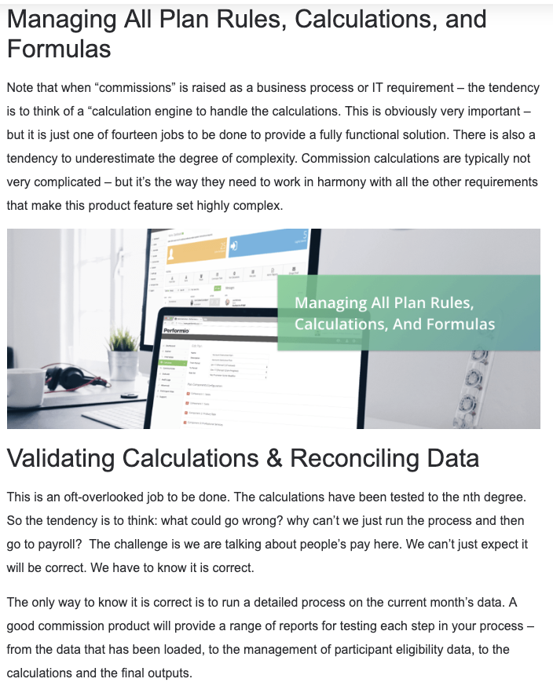

*-from a Performio “Manage Sales Commissions In Salesforce” online article.*

# KT Papers, presentations, and Wiki links

The initial reason to write this document was to capture a KT from 24-year Intuit Business Analyst veteran, Cindy Orchard. This section highlights and links the set of wiki and Box links which introduce what she was as current problems to address. We fortified her concentrated library set with introductory lectures, Q&A sessions, and examples using Salesforce. The previous sections in this appendix are ancillary data and notes supplied by Business Analyst, Sweta Parekh.

The following lists are Cindy’s link-set titles with abbreviated descriptions.

## Box links

The following represents the first set of Box links Cindy numbered so I would read them in order:

1. “[Commission data confidence / revamp](https://intuit.app.box.com/file/487791148490)”  
   2016 sales slide decks meant to show updates in **sales tools and roadmap for 2017**
2. [FROM_sales to commissions flow.pdf](https://intuit.app.box.com/file/487769403388?search=Sales+to+Commissions+diagram)  
   Sales data and component **flow chart** from Salesforce as a frontend to Callidus database. *See* *Related Information* *for graphic.*
3. [Business Unit Attribution Rules & Forecasting Alignment](https://intuit.app.box.com/file/487789693188?sb=/metadata) 🔺  
   The Role of Sales and Implications on **Forecasting & Metrics**
4. [Crediting Rules: Accountant Telesales](https://intuit.app.box.com/file/487799679919?sb=/metadata) *-* **Adjustment Request, pre-validation**s

## Past Wiki links

The following represents the next set of links that follows up on the Box pages:

* Wiki link: [Online Order Experience](https://wiki.intuit.com/display/SalesTech/Online+Order+Experience) (OOE)  
  Stub of a page for a sales process for all Online Products Purchases
* Wiki link: [Online Products](https://wiki.intuit.com/display/SalesTech/Online+Products)  
  A grid of instruction links for sales people to see screen captures of selling a product, or viewing billing. Some videos without sound. Some videos use a non-standard player.
* Wiki link: [OOE Project Work](https://wiki.intuit.com/pages/viewpage.action?spaceKey=SalesTech&title=OOE+Project+Work)  
  Online Sales Experience Recordings and deck.

## Live presentations

The following is a summary of talks Cindy presented to me over a 3-week period to introduce to sales processes, payments introduction, and data in the systems.

The **audience for the commission trigger mapping document** are people working automating commissions calculations processes or sales processes.

### Using Salesforce to see a lead, accounts, and opportunities

Several examples of using Salesforce for standard telephone ABC sales and one Managed account for an accountant (*Relationship Type is Accountant-Client*)

### Payments and NextGen

In depth discussion about how orders begins in Salesforce, sends/integrates information to different systems, depending on the product type.

The integrated data goes back into Salesforce staging database to add business rules then if a commission is earned it flows into Callidus.

Currently we are sending data to multiple places between sale and commission. NextGen is integrating AWS, as a single system for unified business rule analysis which is simplifying data flow to Callidus integrations. This way data that contains sales credits directly flows into Callidus.

## Excel Summary Sheets - a summary of her last thoughts on Salesforce, Callidus and Commissions

The main culmination of Cindy’s KT is in this excel file. She started using the first sheet during our meetings and during long gaps between meetings she added more ideas.  
[Documenting Comp Process and Commissions hooks-triggers 2019_07_26_CO.xlsx](https://drive.google.com/file/d/1JM11lioBBqn-2NFO0UnXqrGMQeTDtD3H/view?usp=sharing)

### SOW and links tab

This tab view lists main goals to document or map Sales Process Flows and the triggers that Callidus uses for Sales Credit commissions.

The people I have contacted as SMEs are:

* Geren Waters for Callidus
* Andrew (Andy) Scott is the leader on Commissions tech for the Comp Team.
* Philip Hill, an engineer who works with Salesforce APIs to Callidus
* Paddi Iyer, an engineer who works with Salesforce APIs to Callidus

Cindy wants the best selling **products standard order flows** mapped. Products called out are:

* ABC and QB Pro
* QB sold through managed accounts (accountants/resellers)
* ABC for *Merchant Account services*

### 

### Background tab

This tab view has a wide category of topics which all culminate in triggering a commission.

It lists people, processes, and tips and tricks sales people use and some of the internal lingo they use. Specifically she called out for the following sales people types for different sales types such as:

|  |  |
| --- | --- |
| Sales people types | Different sales types |
| * Account Owner * Payroll Account Manager * Accountant Telesales Agent * SAM (Senior Account Manager?) | * Membership * Direct sale to a Small Business customer * Managed Account sale through an accountant or retail store |

She then describes the sales pipeline from Input to Order/Subscription.

She adds a list of places she expects triggers to be located. Specifically, all items listed are “needed to trigger **Callidus** to count a sales event as booked”.

* Who
* When
* What
* Amount-Price

The same events are evaluated for clawbacks.

### Payments tab

This tab view has three headers and a link to a wiki titled, Selling Payments Requirements & Research. The three headers are as follows with scenarios defined in tables and lists

#### Salesforce

This section loosely describes two agents in a Lead pass example detailing steps with Salesforce fields and associated APIs such as:

* Opportunity_Number_c__c for Opportunity Number information
* OfferCode__c for Offer Code information

#### Product System

This section lists some possible states that **Application Status** and **Transaction Count** can be in and how it relates to commission triggers. I believe this is from a Salesforce viewpoint..

#### Billing System (A-product)

This section lists date fields but Cindy notes she doesn’t know the Callidus APIs.

### 

### Order tab

This tab view only lists a link to [Sweta’s data flow diagram](https://nolink.com). A detail is pasted in the following paragraph (see ABC and ABC for Accountant Data Flow and Commission Trigger Events for full commented chart):  
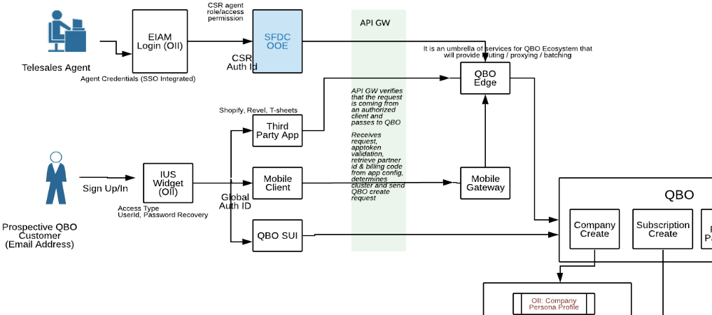

### Sales Teams tab

This tab view gives information on where to reach various sales teams and what their specialties are.

Specifically this tab has a short list of SMEs, a link, and one table. The link is to [Sales Consultant Personas and geographic locations.](https://nolink.com)

The SMEs listed are:

* **Steve Haney** (Telesales) & Erik Swett (Managed Accounts) can give you the right contact to speak with for each of the teams to confirm Standard vs Exception Sales processes
* **Rodney Fowler** is a good resource for who sells what and what triggers SI sales credit (like this to match Commissions, but doesn't always)

Useful table of sales teams and geographic locations. *A truncated table example* follows

|  |  |  |
| --- | --- | --- |
| PSG | CamSur, Philippines |  |
| Campaigns-FBG | Fredericksburg, VA |  |
| Sales Innovation - Account Development | Fredericksburg, VA |  |
| QuickBooks Capital | Fredericksburg, VA |  |
| Payroll | Fredericksburg, VA |  |
| ... | ... |  |
| QB | Tucson, AZ |  |
| Emerging Channels/IRP/Franchise | Woodland Hills, CA | *James (Shannon) Brooks tracks these sales* |

### Examples Callidus Stage in SF tab

This tab view shows example data in a Salesforce(?) or Callidus(?) 9-column table. The Salesforce data tables were Cindy specialty, but I am unsure of how this informs us at this moment.   
A *truncated table* example follows:

|  |  |  |  |  |  |  |  |
| --- | --- | --- | --- | --- | --- | --- | --- |
| ID | a232A000002gRUoQAM | a232A000002gRUtQAM | Notes | a232A000002gRwTQAU | a232A000002gSaDQAU | a232A000002gRoHQAU | a232A000002gSoAQAU |
| OWNERID | 005i0000003UfBeAAK | 005i0000003UfBeAAK | Sales Credit to/from | 005i0000003UfBeAAK | 005i0000000qTgFAAU | 005i0000003UfBeAAK | 005i0000003UfBeAAK |
| ISDELETED | FALSE | FALSE |  | FALSE | FALSE | FALSE | FALSE |
| NAME | 2082146 | 2082147 |  | 2082647 | 2083423 | 2082672 | 2084192 |
| CURRENCYISOCODE | AUD | USD |  | USD | USD | USD | CAD |
| CREATEDDATE | 2019-07-16T00:02:33.000Z | 2019-07-16T00:02:43.000Z |  | 2019-07-16T04:05:44.000Z | 2019-07-16T06:58:56.000Z | 2019-07-16T04:05:56.000Z | 2019-07-16T07:37:43.000Z |
| CREATEDBYID | 005i0000003UfBeAAK | 005i0000003UfBeAAK | Lead Pass Credit | 005i0000003UfBeAAK | 005i0000000qTgFAAU | 005i0000003UfBeAAK | 005i0000003UfBeAAK |
| LASTMODIFIEDDATE | 2019-07-16T00:02:34.000Z | 2019-07-16T00:02:43.000Z |  | 2019-07-16T19:49:37.000Z | 2019-07-17T22:58:28.000Z | 2019-07-20T11:43:37.000Z | 2019-07-16T11:01:32.000Z |
| LASTMODIFIEDBYID | 005i0000003UfBeAAK | 005i0000003UfBeAAK |  | 005i0000003UfBeAAK | 005i0000003UfBeAAK | 005i0000003UfBeAAK | 005i000000347MUAAY |
| SYSTEMMODSTAMP | 2019-07-16T00:02:34.000Z | 2019-07-16T00:02:43.000Z |  | 2019-07-16T19:49:37.000Z | 2019-07-17T22:58:28.000Z | 2019-07-20T11:43:37.000Z | 2019-07-16T11:01:32.000Z |

### 

### Managed tab

This tab view is an example of how a standard Managed Account sale occurs with a Salesperson, an accountant, and a (new?) small business-accountant client of the main accountant.  
In spite of the unusual spacing which impedes quick reading, I believe this could be of use, however, there are online ILN modules that cover this scenario.

>> The bottom line Cindy wanted to touch on in the Managed tab is about commissions from Managed Accounts. <<

The following quote by Cindy is a critical bit of information. It in reference to an Intuit Managed Account Salesperson and The Accountant:

*… They are "connected" by the Account Relationship record where The Accountant is the Parent Account and the (new?) small business-accountant client is the Related Account AND the Relationship Type is Accountant-Client.*

*(You) can only use one relationship ... to get (a) sales credit. (It) needs (the) Primary Flag = 1 and AIC = TRUE; these are both set at the time that the relationship is first established.*

*Hence, the Relationship Established On Date <= the SignUp date <= GNS Date.*

* Sales Credit for Wholesale sales count at SignUp or at MigrateIN *if* MigrateIn< FCD (ie FCD is null at time of Migrate In).
* Otherwise Sales credit counts at First Charge Date for Bill My Client.
* GNS Date get populated according to the two rules above.

1. If ABC user *A* changes accountants but keeps their ABC license, then the original salesperson associated with the first accountant remains attached to ABC user *A’*s license, even if they begin working with another accountant linked to Intuit.
2. *Mr. Smith is the engineer-author of the Callidus Reconciliation tools v1 and v2*
3. *Limiting critical data to one style of delivery filters out many people.*
4. *Difficulty in library navigation is a personal observation expressed only in this paper for clarity of Conclusion.*
5. *The Compensation team is Geren Waters and Andrew (Andy) Scott who are the Callidus experts.*